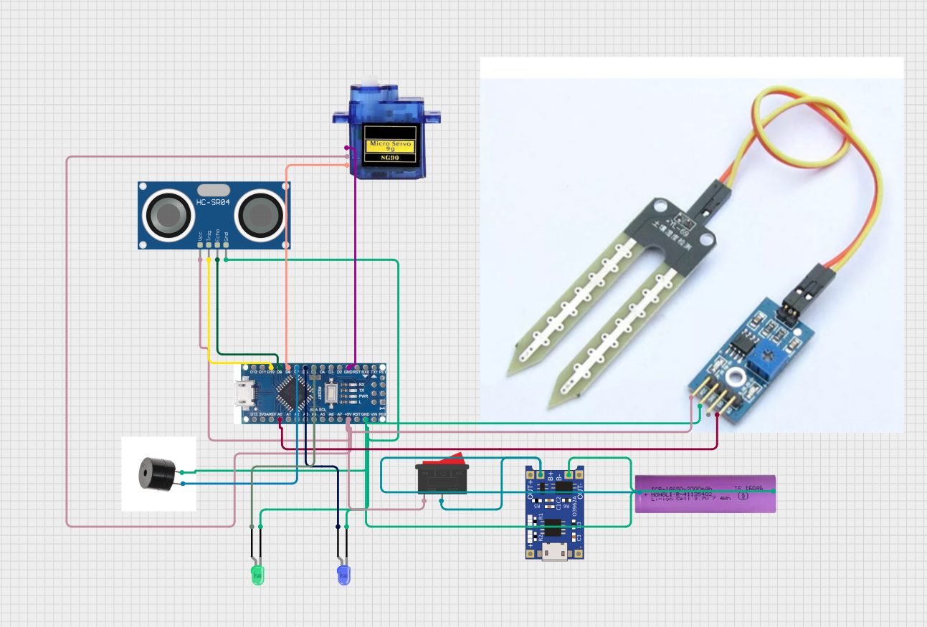

3.7 VOLT LION BATTERY

CHARGING MODULE

SWITCH

BLUE LED

GREEN LED

BUZZER

ARDUINO NANO

SOIL MOISTURE SENSORS

SERVO MOTOR

ULTRASONIC SENSOR

DRY & WET GARBAGE SEPERATORS [ CIRCUIT DESIGN]